# BARS NodeJS FAQs

## What are the usual libraries to be used?

* Express
* Multer
* MongoDB
* Mongoose

## What is the format of the endpoint?

* app.post( ... )

## I don’t have an access with udemy/pluralsight, can I ask for other resources?/Can I use other resources aside from udemy /pluralsight?

* Yes, you can use/find other resources other than udemy/pluralsight.
* You can check these useful links:
* [JavaScript Array map() Method (w3schools.com)](https://www.w3schools.com/jsref/jsref_map.asp)
* <https://youtu.be/vjf774RKrLc>
* <https://www.youtube.com/watch?v=Oe421EPjeBE>
* <https://youtu.be/jS4aFq5-91M>
* h[ttps://youtu.be/Oe421EPjeBE](https://youtu.be/Oe421EPjeBE)
* <https://youtu.be/pKd0Rpw7O48>
* <https://www.youtube.com/watch?v=8kArXUpQAaY>
* [Query and Projection Operators — MongoDB Manual](https://docs.mongodb.com/manual/reference/operator/query/)
* <https://www.youtube.com/watch?v=2Ntnlv-nuV8>

## I’m having a problem doing the JEST Testing, do you have other resources for it?

* You can check the following links:
* <https://accentureatcp.udemy.com/course/nodejs-unit-testing-in-depth/learn/lecture/10202708#overview>
* <https://accentureatcp.udemy.com/?next=%2Fcourse%2Funit-testing-and-test-driven-development-in-nodejs%2Flearn%2Flecture%2F10855468#overview>

## Where can I put the backup of my project and where to send it after?

* For saving a backup and sending your project, you can use: <https://innersource.accenture.com/>  and create your own repository.
* Repository Name: bars-service.eid (*e.g. bars-service.aira.fauna.g.ansay*)
* Give permission to atcp.ies.cae.java.faculty

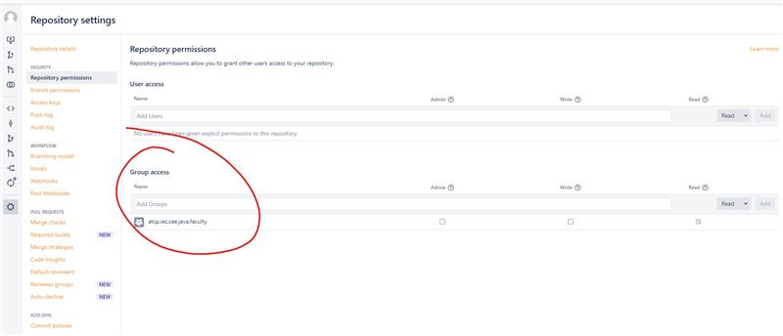

* See ***Innersource Instruction v1.2*** in the BARS Helpful Documents

## How to import/setup the database?

* Download mongoDB with mongoDB Compass for the GUI
* MongoDB server should be running automatically
* Open mongoDB compass
* Click new connection and connect to **mongodb://127.0.0.1:27017**
* If there are no pop-ups for error, then it's connected
* Go back to Visual Studio Code
* Open a new terminal
* Install mongodb npm package (npm install mogodb)
* Use command node bars_db.js to import the database given named **bars_db.js**
* Go back to Compass and check if the db created a new collection named ('billings')
* On your code, use the url **mongodb://127.0.0.1:27017** when connecting to the db

## I’m confused on where to start with the assessment. Can you advise?

* Set up the database first. Check FAQ #6.
* Read all the documents given. It will help you understand the process flow of the assessment.
* Start with creating the upload folder
* Do the file upload process as well as reading the file, start with the validation for checking it the file is a txt/csv file, it not, return an error saying that the file is not supported for processing.
* If the file is valid (txt/csv) start with the file processor, check first if the file is empty to add the validation. Next, check the parameter format starting from the billing cycle, start date then end date then return the validation if it has any error. If none, check the database if the data are valid and present to the database then return the data. If the file is valid but not on the database, return an error for record not found.

*Note: It is your technique to whether start with the txt or csv or do both in parallel.*

* After creating all of the processes and the features of the assessment, do the JEST Testing then do the SonarQube test.